

**ASRC**

***Onboard Learning Resource***

**Design Document**



**Prepared by:** Team Parrots

**Version: 3.0**

**Date: *12/8/2019***

**Sponsors: Joshua Jackson, Michelle Darby, ASRC Federal**

**Table of Contents**

1. ***Introduction***

**1.1 Purpose 3**

**1.2 Scope 3**

**1.3 System Environment 3**

**1.4 I/O Requirements 3**

**1.5 Architecture 4**

**1.5.1 Developmental View 4**

**1.6 UI Design 5**

**1.6.1 Login 5**

**1.6.2.1 Homepage (Mentor) 5**

**1.6.2.2 Homepage (Employee) 6**

**1.6.3 Take a Quiz 6**

**1.6.4 Pre-Quiz Page 7**

**1.6.5 Create a Quiz Manually 7**

**1.6.6 Manage a Quiz (Mentor) 8**

**1.6.7 Manage a Quiz (Employee) 8**

**1.6.8 Edit a Quiz 9**

**1.6.9 View Users 9**

**1.6.10 Create a New User 10**

**1.6.11 Manage a User 10**

**1.6.12 Manage Subjects 11**

1. ***Use Case Diagrams***

**2.1 Login Use Case Diagram 12**

**2.2 Create Quiz Manually Use Case Diagram 13**

**2.3 Manage a Quiz Use Case Diagram 14**

**2.4 Managing Users Use Case Diagram 15**

**2.5 Take a Quiz Use Case Diagram 16**

1. ***Activity Diagrams***

**3.1 Login Activity Diagram 17**

**3.2 Take a Quiz Diagram 18**

**3.3 Create a Quiz Manually 19**

**3.4 Viewing a User 20**

**3.5 Manage Subjects 21**

1. ***Sequence Diagrams***

**4.1 Login 22**

**4.2 Take a Quiz 23**

**4.3 Create Quiz Info 24**

**4.4 Create Quiz Questions 25**

**4.5 Manage Quizzes 26**

**4.6 Taking a Quiz 27**

**4.7 Grading Questions 28**

1. ***Glossary***

***1. Introduction***

**1.1 Purpose**

This document will go over in detail, the design and architecture that is currently present in the Onboard Learning Resource Project website.

**1.2 Scope**

The main goal of the Onboard Learning Resource Project website is to provide a quiz taking and editing system that can be used by ASRC employees to test their knowledge of the corporation and create a fun and easy to use application that will ease the induction of new associates. The additional goals of onboarding are to socialize new hires within the organization, shorten new hire time to productivity and encourage long-term retention.

**1.3 System Environment**

The Onboarding Online Learning Resources application must run on the Windows 10 O/S and within the Google Chrome and Microsoft Edge browsers.

**1.4 I/O Requirements**

The Onboarding Online Learning Resources application must be able to read and parse input files with two distinct datasets (keyword and definition), separated by a delimiter, comma, semicolon, tab (e.g. Microsoft Excel or a text file, or by copy->paste into a text area where text is delimited). This data would be stored into user-created datasets that can be used by everyone, but read-only except by the creator of that dataset. This protects admin-created datasets from being overwritten or modified.

**1.5 Architecture**

**1.5.1 Developmental View**

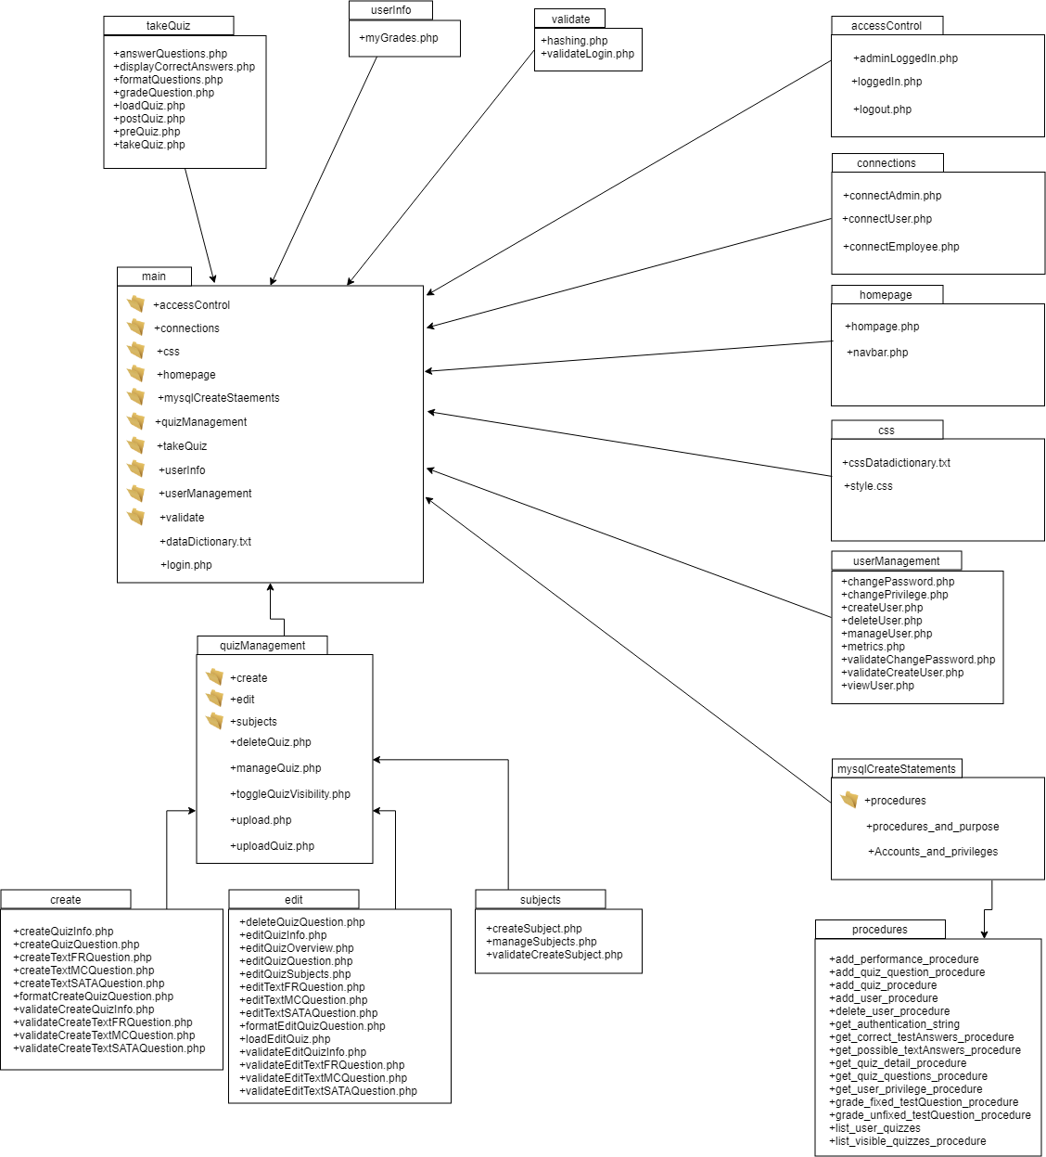

**1.6 UI Design**

This section will provide snapshots of key interfaces that the employees and mentors will interact with within the Onboard Learning Resource Project. Snapshots are provided so current design can be accurately reflected but also show possibilities of change in the future.

**1.6.1 Login** 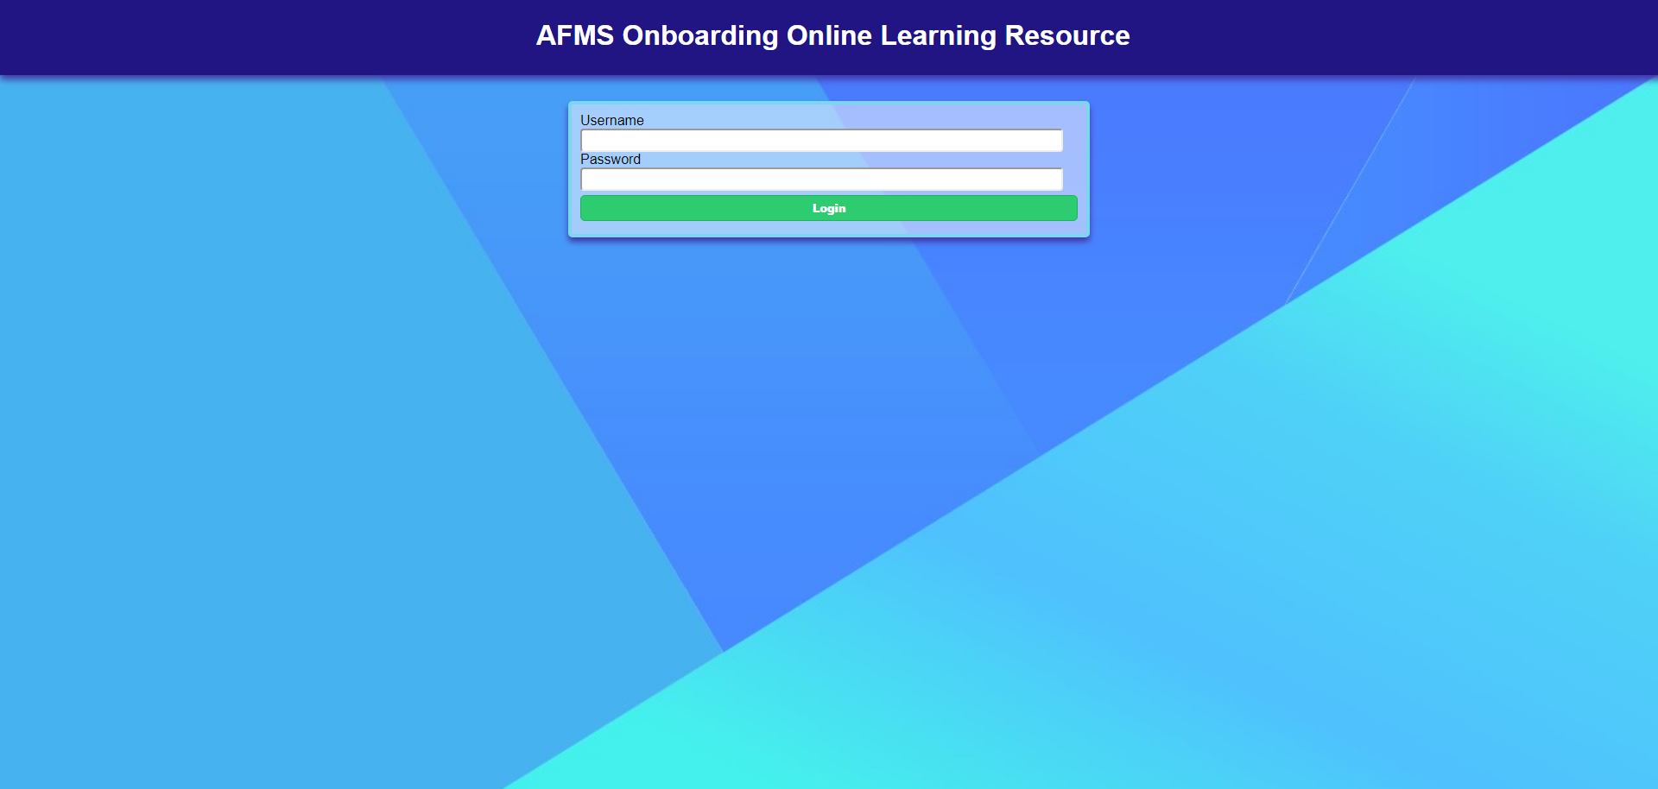

**1.6.2.1 Homepage (Mentor)**

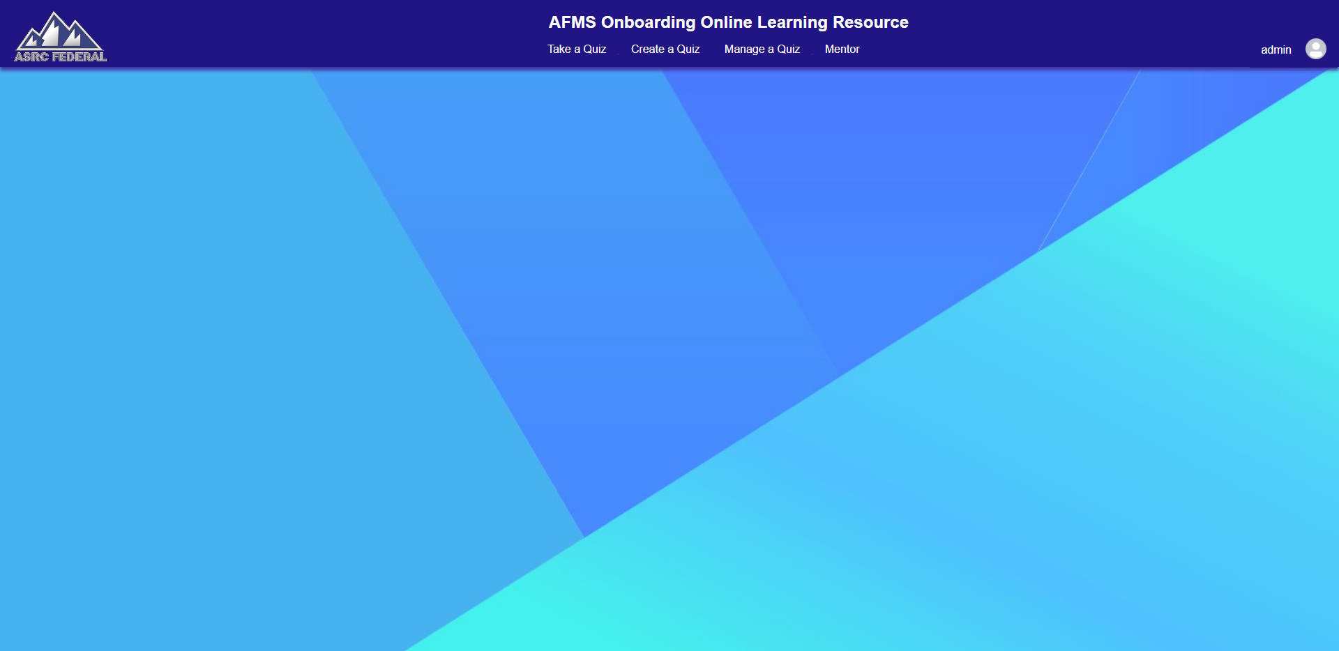

**1.6.2.2 Homepage (Employee)**

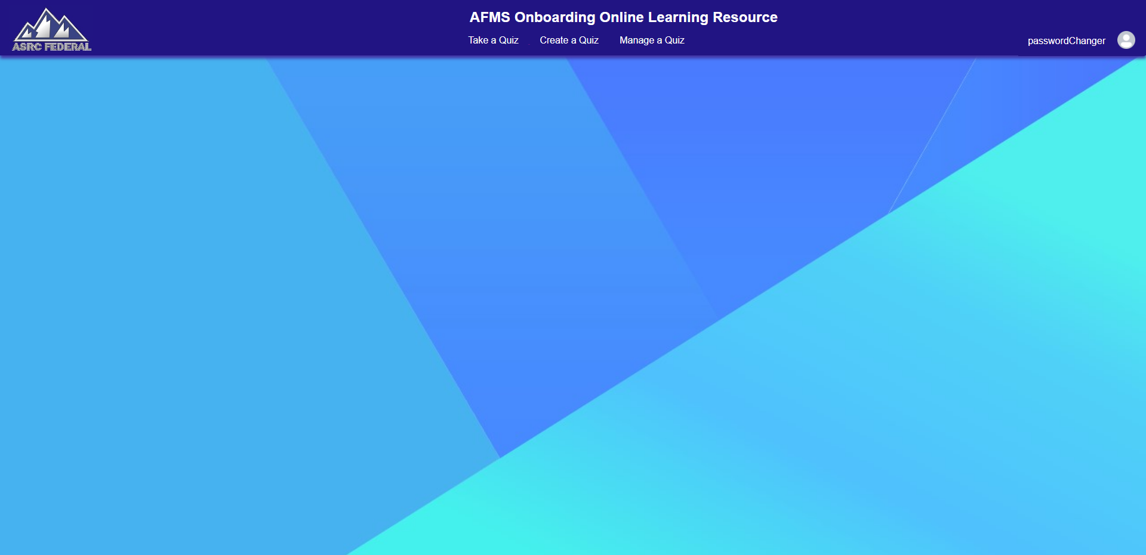

**1.6.3 Take a Quiz**

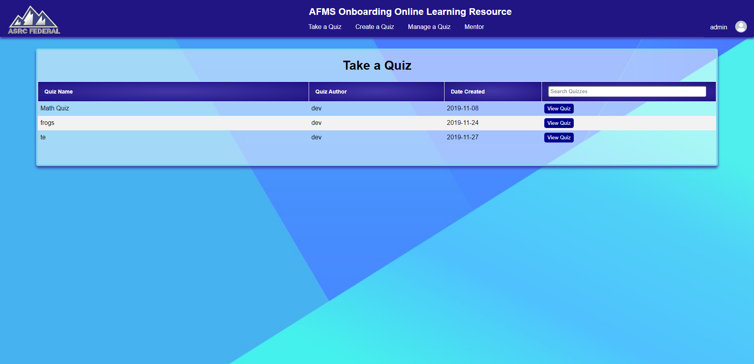

**1.6.4 Pre-Quiz Page**

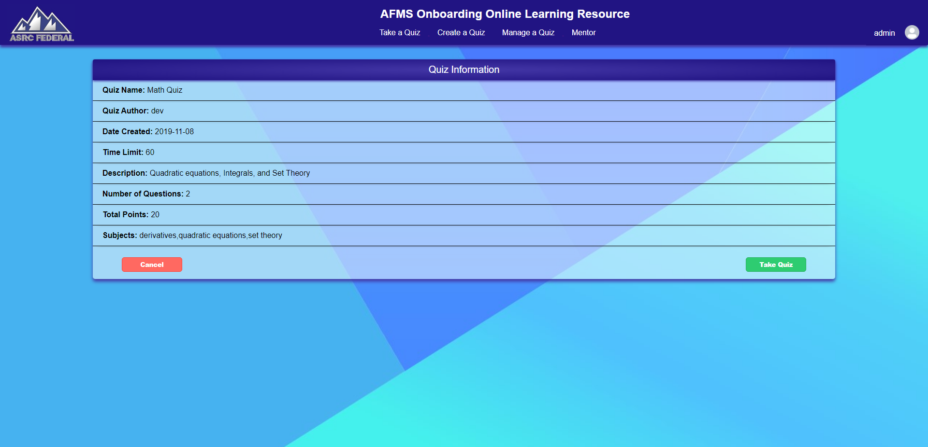

**1.6.5 Create a Quiz Manually**

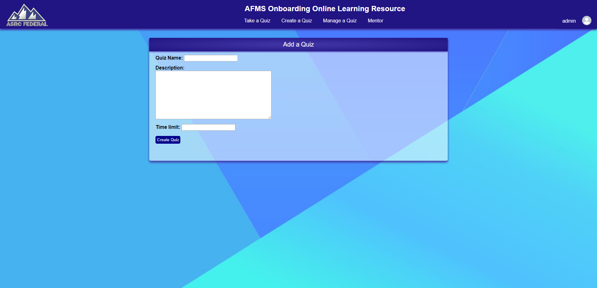

**1.6.6 Manage a Quiz (Mentor)**

Note: Employees may only manage their own quizzes but mentors are able to manage all employee’s and mentor’s quizzes.

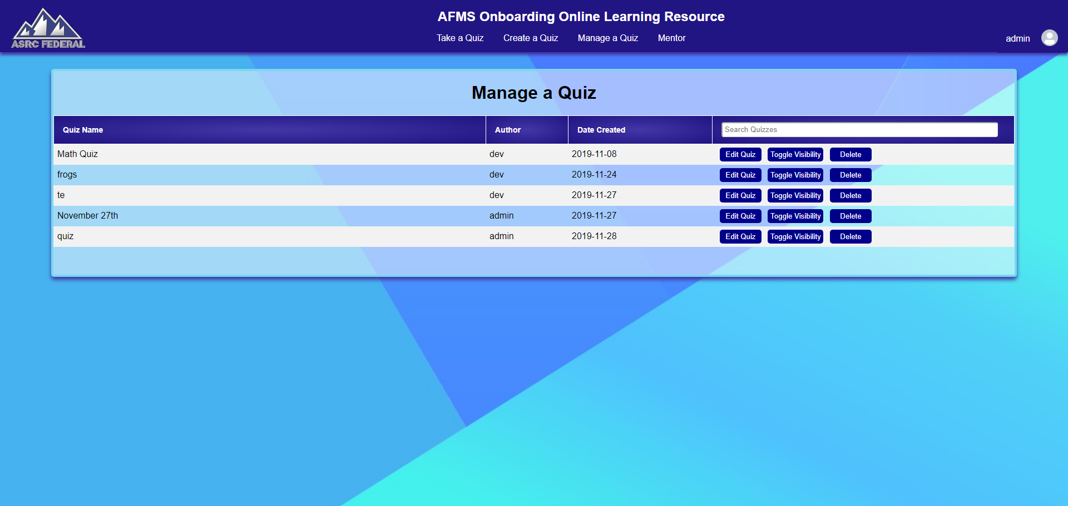

**1.6.7 Manage a Quiz (Employee)**

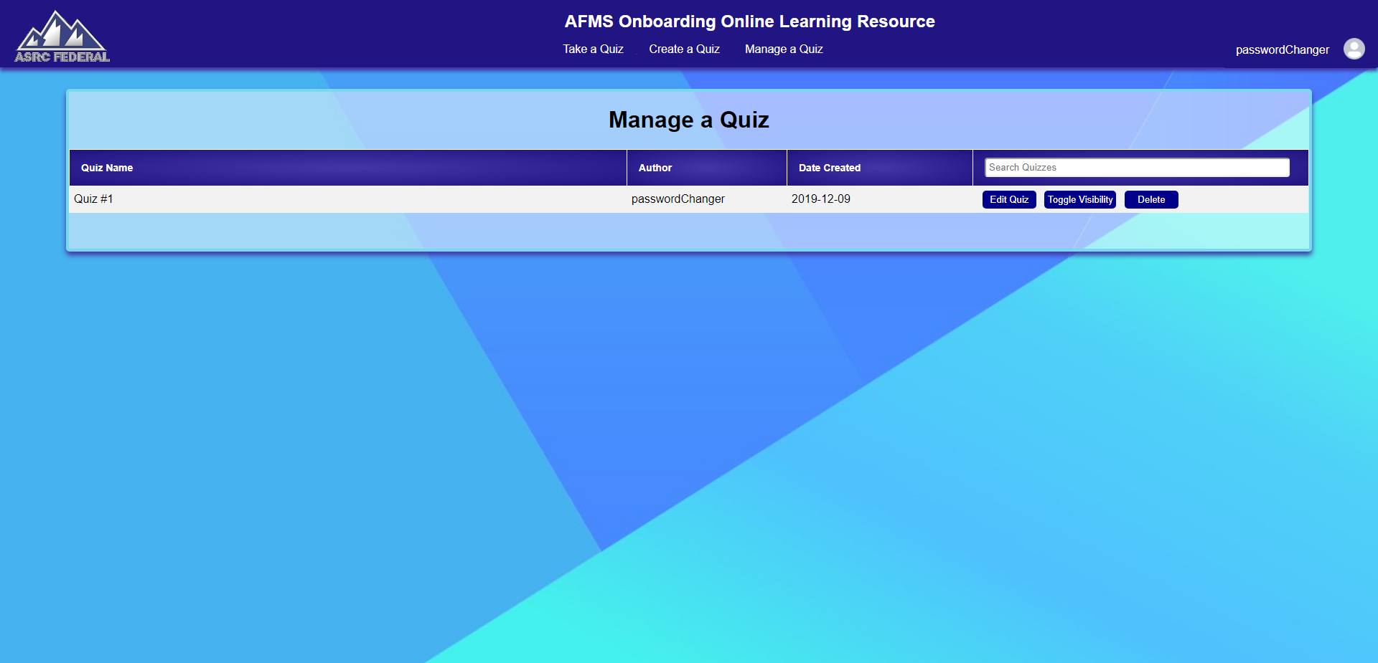

**1.6.8 Edit a Quiz**

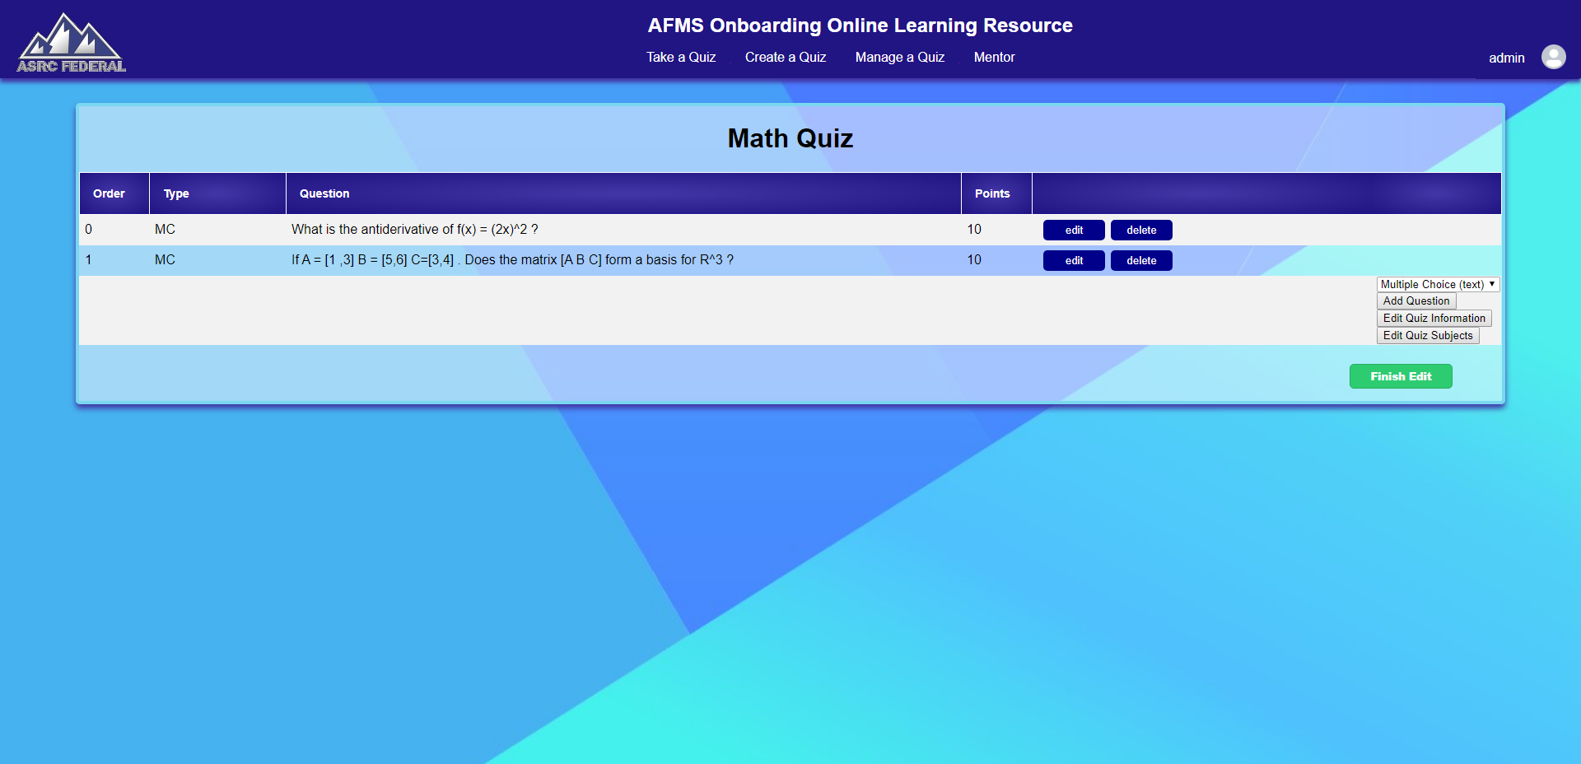

**1.6.9 View Users**

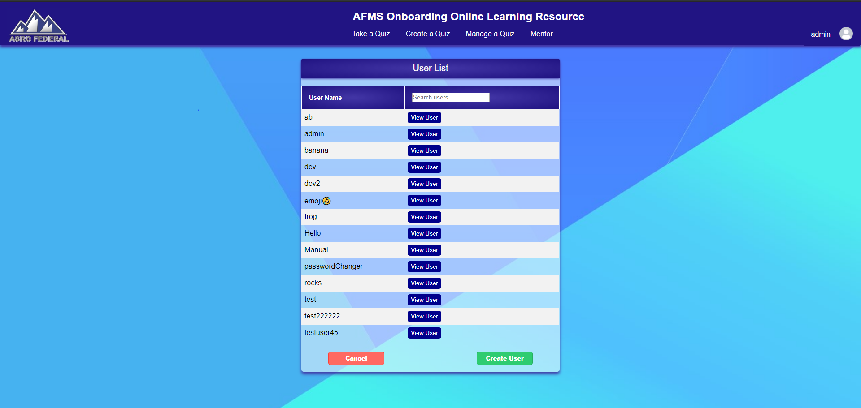

**1.6.10 Create a New User**

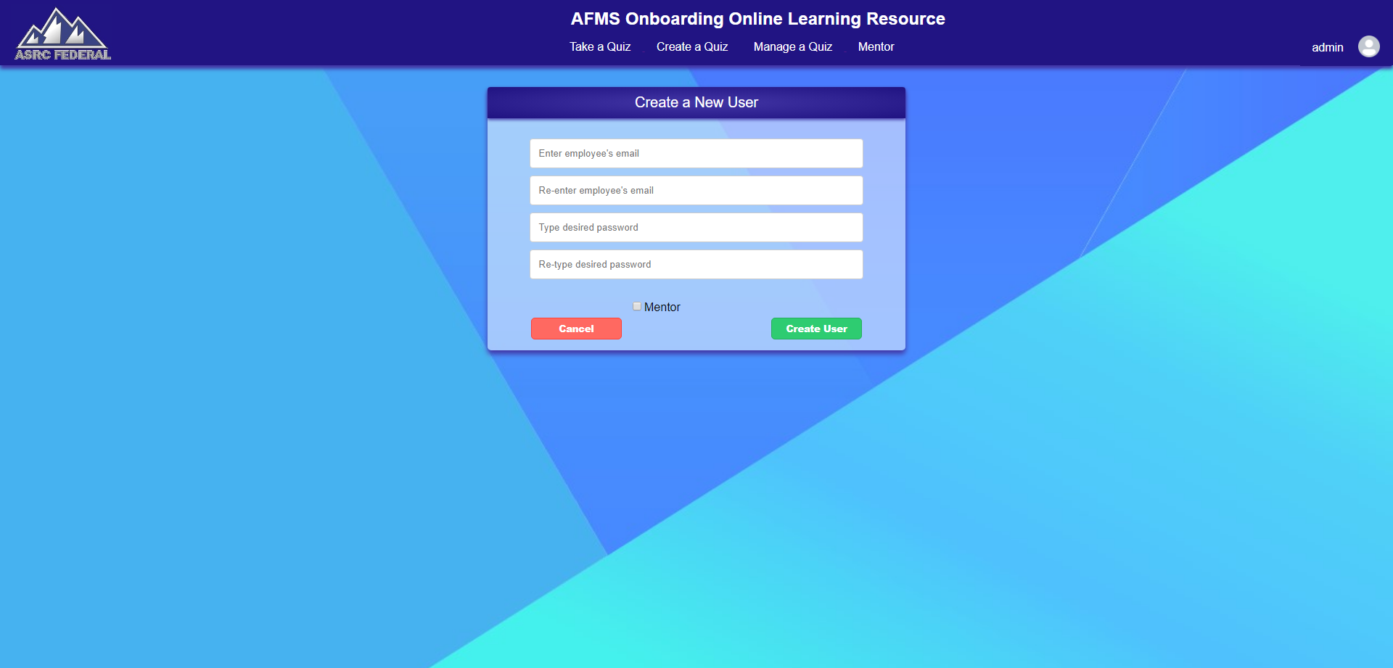

**1.6.11 Manage a User**

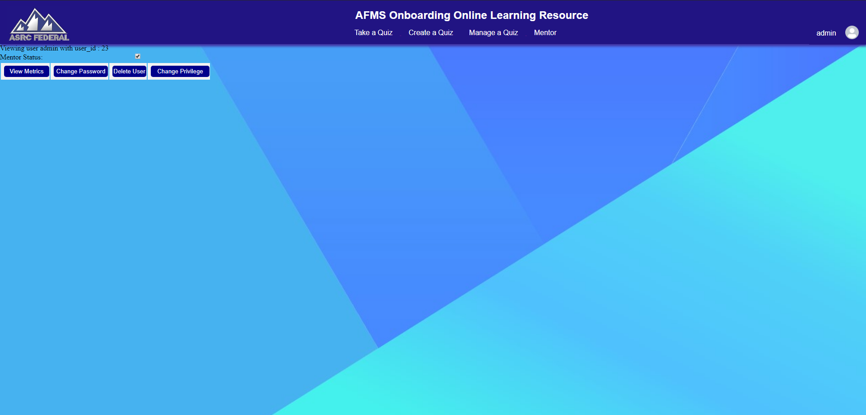

**1.6.12 Manage Subjects**

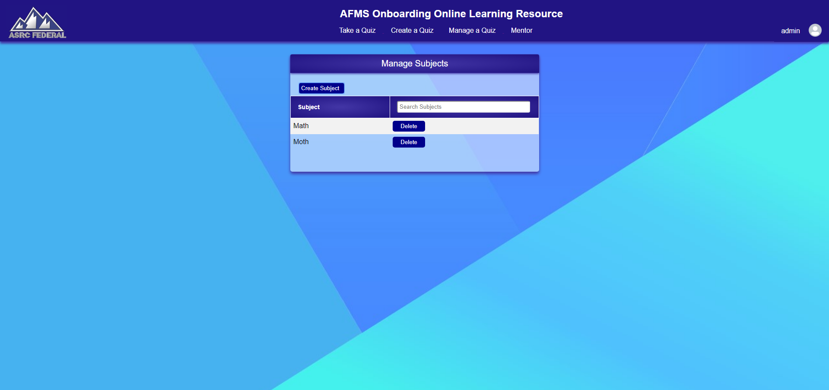

***2. Use Case Diagrams***

The use case diagrams detailed in the sections below will depict the actions that an employee and a mentor can take on the website. An Employee is defined as a user that can utilize the website without access to mentor restricted features such as managing all quizzes and creating new users. A mentor is defined as a user that has full access to the website.

**2.1 Login Use Case Diagram**

The use case diagram in this section shows the actions an employee and a mentor can take on the login page. The credentials the user enters into the username and password fields are compared against the ones stored in the database. If there is no match the user will be notified that they have entered invalid credentials. If the user is successful they will be redirected to the homepage and given access to mentor specific functionality if their level of permission allows.

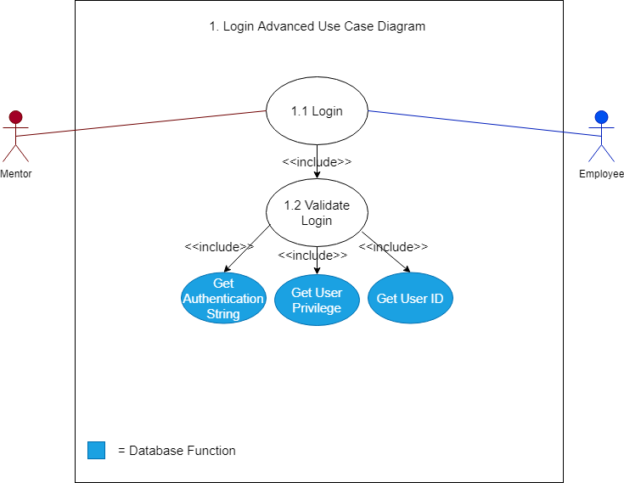

**2.2 Create Quiz Manually Use Case Diagram**

The use case diagram in this section details the actions employees and mentors can take when creating a quiz manually. After a user enters the name of the quiz, it’s description, and the time limit for the quiz they click create quiz and are taken to the editing overview for their quiz. There, they can add, delete, and edit questions as well as edit quiz information.

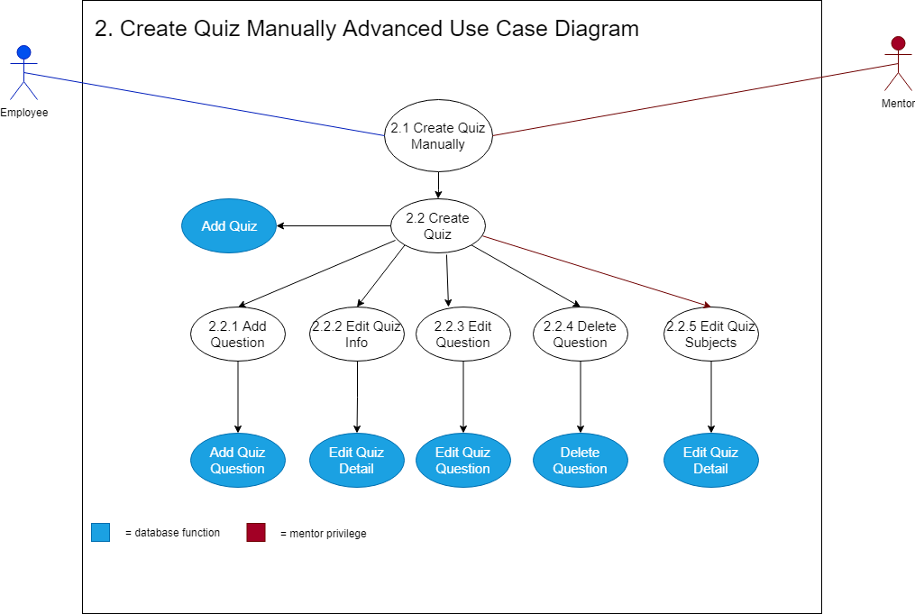

**2.3 Manage a Quiz Use Case Diagram**

The use case diagram in this section details the actions employees and mentors can take when managing a quiz. On the quiz overview page either all of the quizzes in the database (exclusive to mentors) or only the currently logged in employee’s quizzes (exclusive to employees) will be displayed to the user. From this point they can either choose to toggle the visibility of their quiz to all users, edit the quiz, or delete the quiz. If the user decides to edit the quiz they are met with a wide variety of options that are shown below.

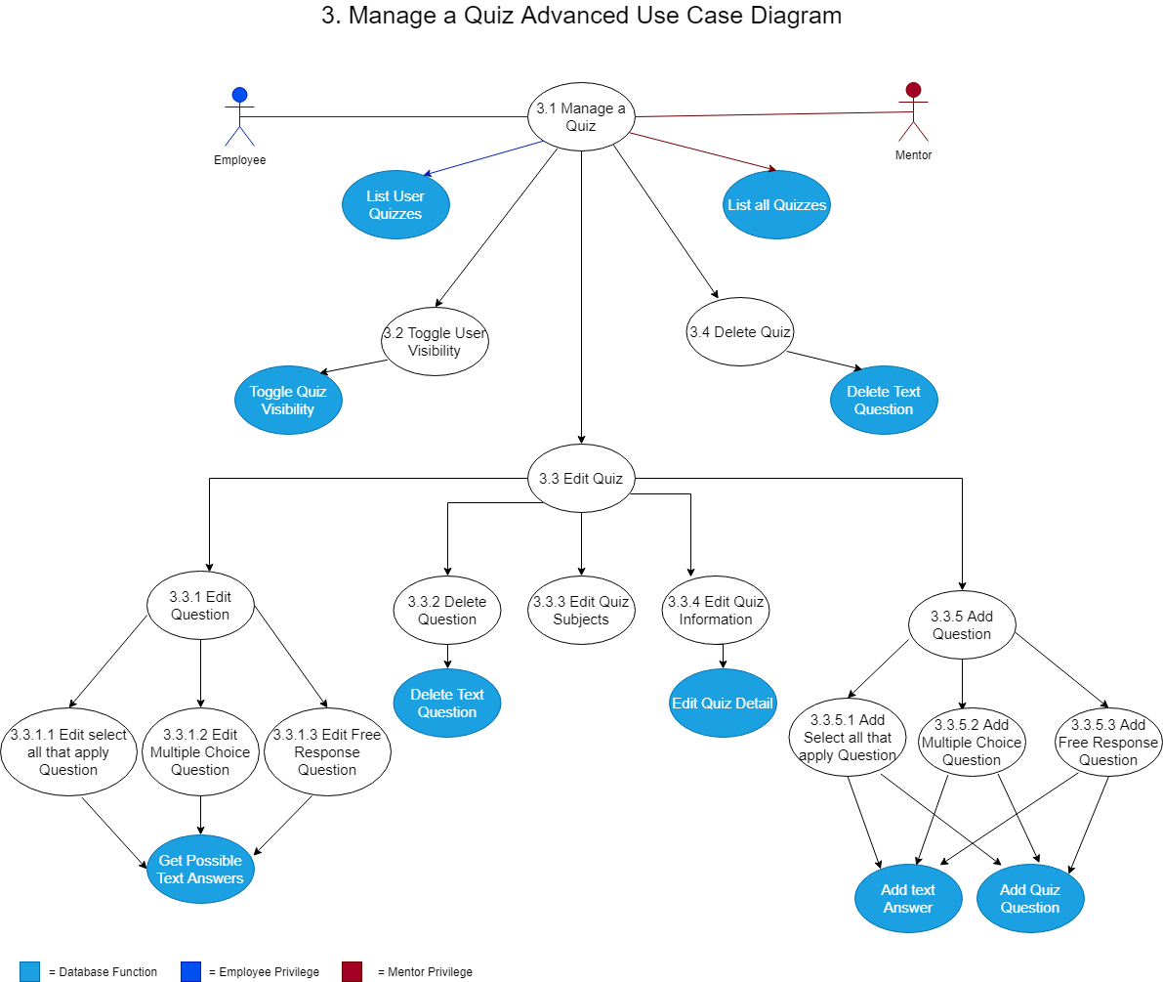

**2.4 Managing Users Use Case Diagram**

The use case diagram in this section details the actions mentors can make when managing other users. When mentors click on the view users tab they are met with the options to either create a new user or manage a currently existing one. If they choose to manage a user they will be met with the screen displayed in section 1.6.11. From here they can view a user’s metrics, change their password, change their privilege to demote or promote to mentor, and delete a user. When creating a new user mentors have the option to immediately make that user an employee or a mentor upon creation.

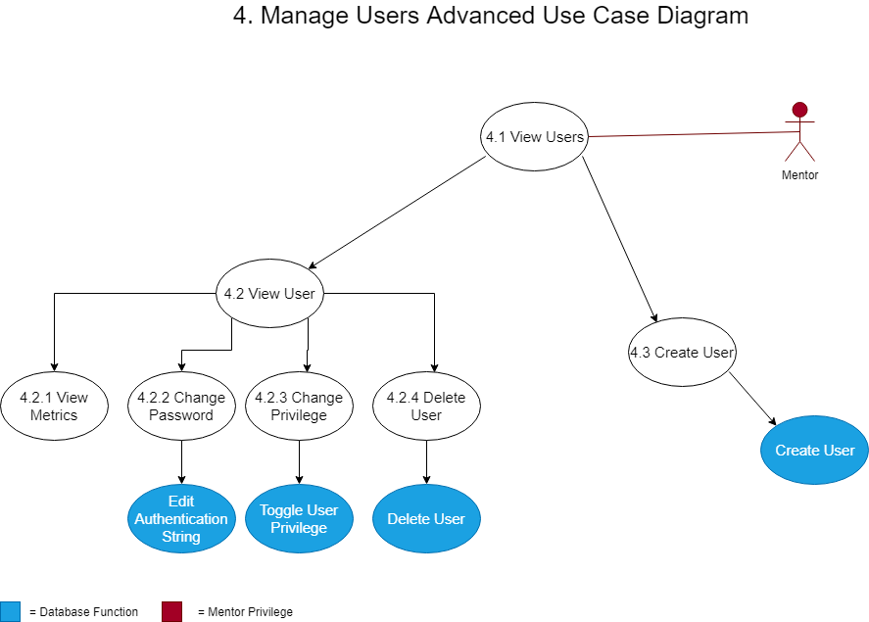

**2.5 Take a Quiz Use Case Diagram**

The use case diagram in this section details the actions mentors and employees can take while taking a quiz. There is a very linear progression to taking a quiz. An employee or mentor will select a quiz from the list of visible quizzes and take the quiz. Once the quiz has been loaded the quiz taker will answer questions one by one, having the correct answer be displayed after answering each question. Once there are no more questions the user is prompted to view their grade which when they are met with the post quiz screen. There the user will be shown their percentage grade, total number of points earned, total number of possible points they could have earned and the elapsed time it took them to take the quiz.

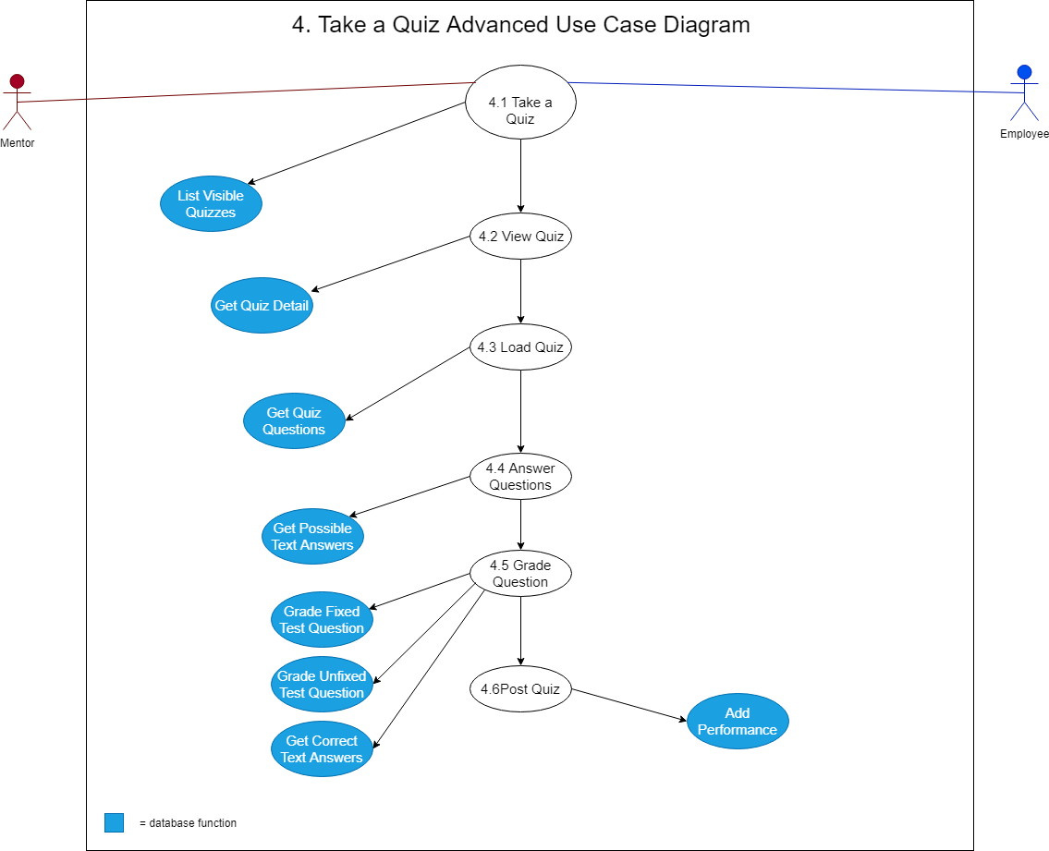

***3. Activity Diagrams***

The activity diagrams in this section detail the paths that an employee and mentor can take on the Onboard Learning Resource Project. The point of these diagrams are to describe the step-by-step workflows of activities to be performed in a system for reaching a specific goal.

**3.1 Login Activity Diagram**

This diagram shows the actions that an employee or a mentor take when successfully logging into the website. Or alternatively when the login info entered into the text fields is incorrect. If a user successfully logins in their privilege is checked before the homepage is displayed to them to ensure that only mentors have access to certain functionalities of the website.

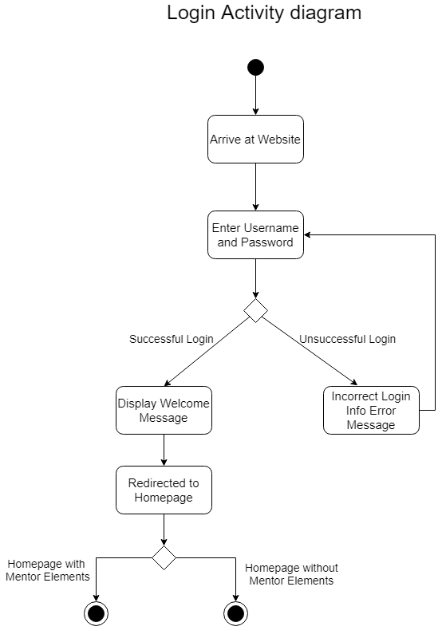

**3.2 Take a Quiz Activity Diagram**

This activity diagrams aims to give a better understanding of the flow of activities when taking a quiz.

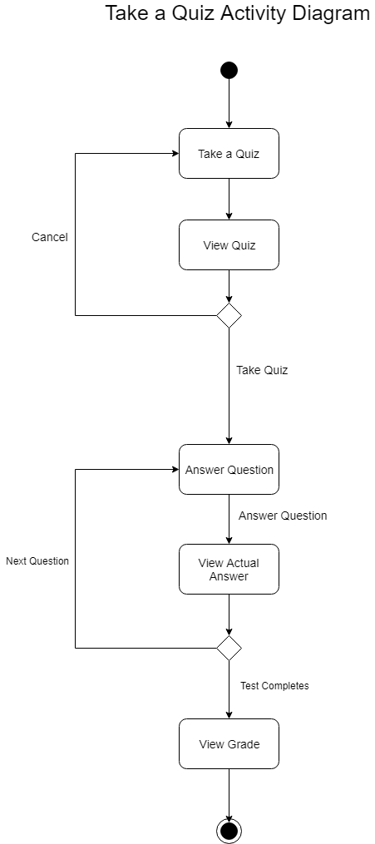

**3.3 Create a Quiz Manually Activity Diagram**

When a user manually creates a quiz they will be prompted for the name of the quiz, its description, and time limit upon creation. After the quiz has been created it is in the database but not visible to all users. The user will be directed to the manage quiz overview where they can edit or add things like questions, subjects (restricted to mentors), and general quiz information.

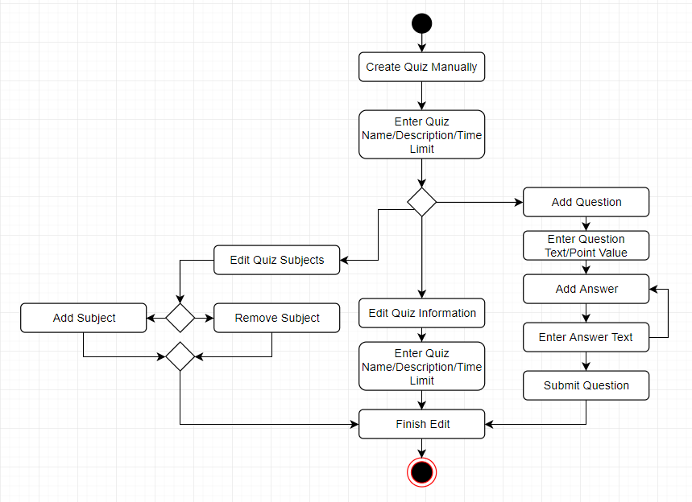

**3.4 Viewing a User**

The functionality for viewing/managing a user is shown in section 2.4 but this activity diagram aims to go more in depth than the use case diagram so you it is obvious which options are available to the mentor in this part of the website’s functionality.

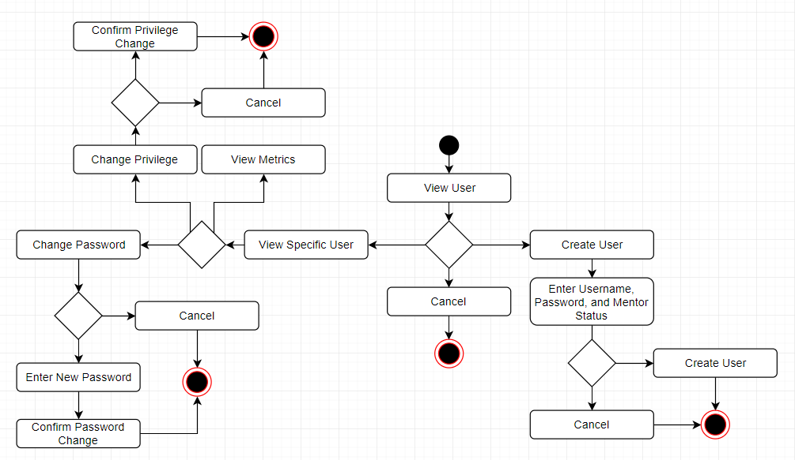

**3.5 Manage Subjects**

Managing subjects is a mentor restricted piece of functionality on the website. Mentors can create and delete subjects that can be added to quizzes to classify them.

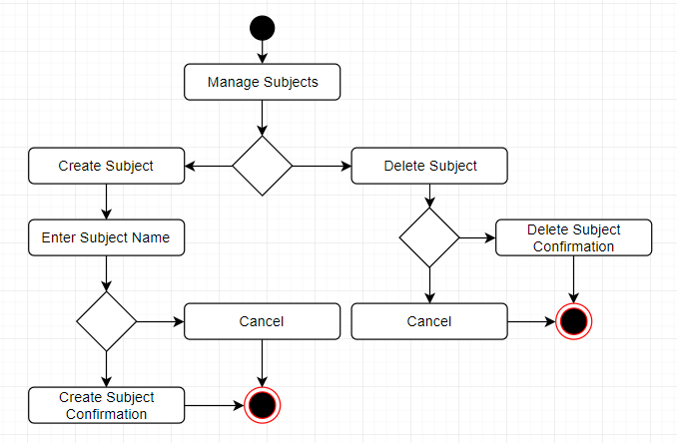

***4. Sequence Diagrams***

Sequence diagrams show how objects communicate with each other in terms of a temporal sequence of messages. The aim of these diagrams are to explicitly show the series of messages and information that are passed between pages on the website in order for certain pieces of functionality to work as intended.

**4.1 Login**

When logging into the website a user will enter their username and password. Once their username and password are submitted, the hash for the password corresponding to the username is fetched from the database. The password is verified using the php built in function password_verify, the user’s privileges and user id are grabbed from the database and they are redirected to the homepage.

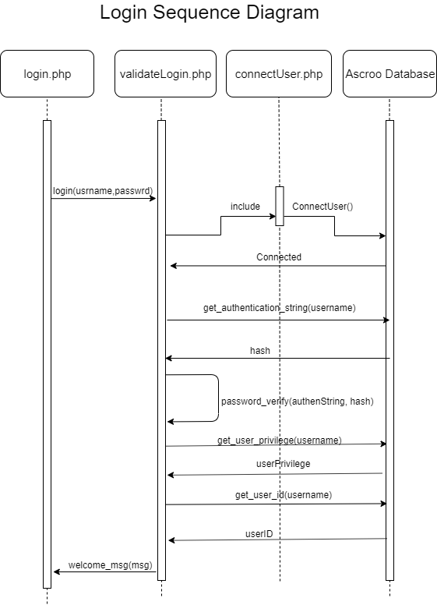

**4.2 Take a Quiz**

This sequence diagram shows how visible quizzes are displayed to the user. Once they reach the take a quiz page they are met with the quizzes that are visible to all users. After connecting to the database a procedure is called and then formatted into a table so the user can view the quizzes available in a streamlined fashion.

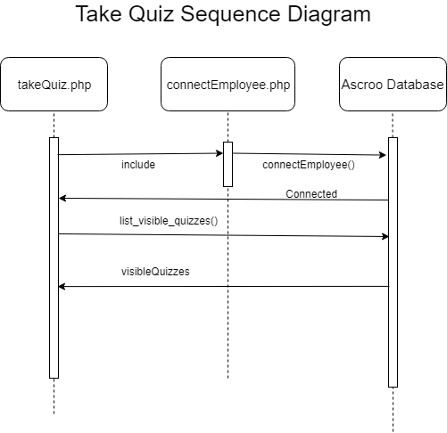

**4.3 Create Quiz Info**

When a user chooses to create a quiz manually they will be prompted to enter the quiz name, description, and time limit. Below are the series of messages passed when a quiz is created.

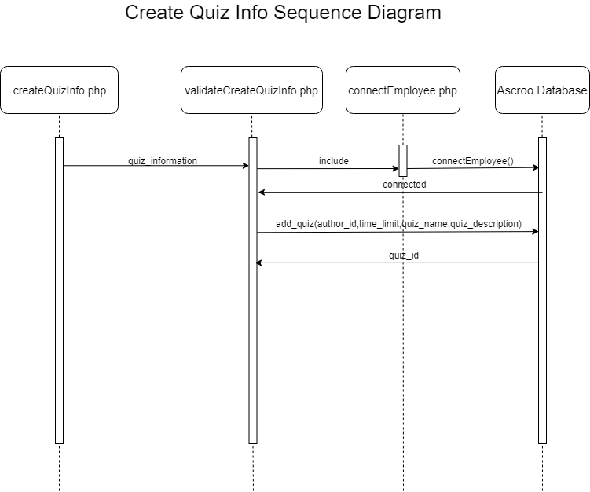

**4.4 Create Quiz Questions**

Below is a series of messages passed when a user wants to add a question to their quiz. They are given a drop down to either select a multiple choice, select all that apply, or a free response question. Depending on which type of question they select, a series of pages are passed information in order to create, validate, and finally add the question and its answer(s)/point value to the database.

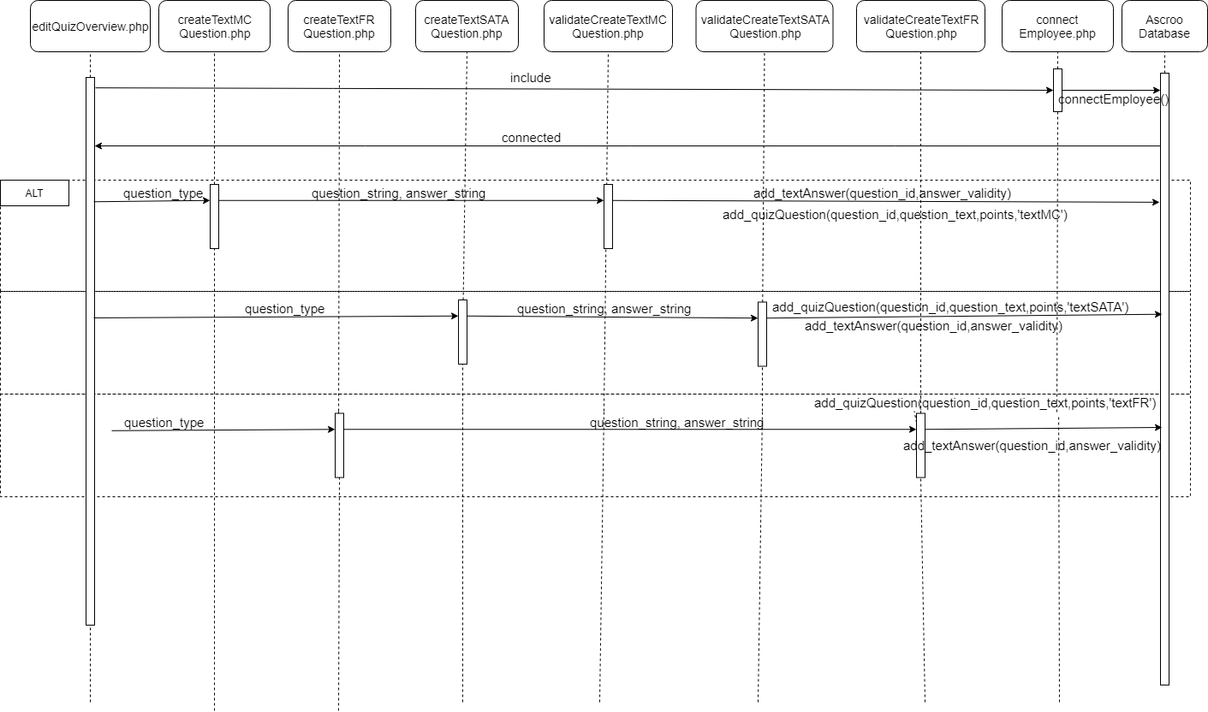

**4.5 Manage Quizzes**

The manage quiz page will only display the currently logged in user’s quizzes if they have employee level privileges. If the current user is a mentor they are able to view all quizzes in the system and manage them as well.

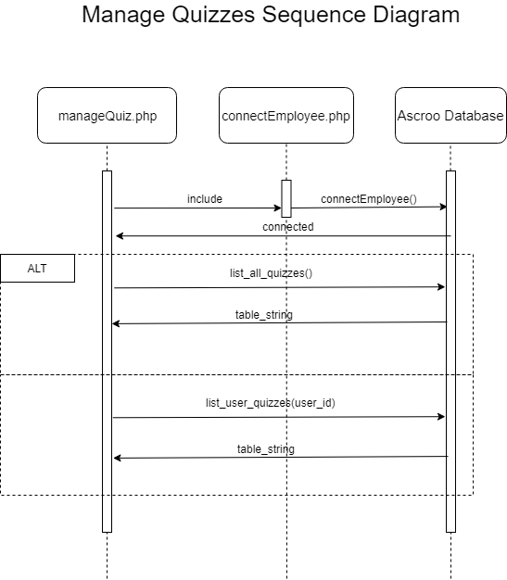

**4.6 Taking a Quiz**

When answering the questions in a test the information about each question is pulled from the database and then formatted once received, so only one question is viewed at a time.

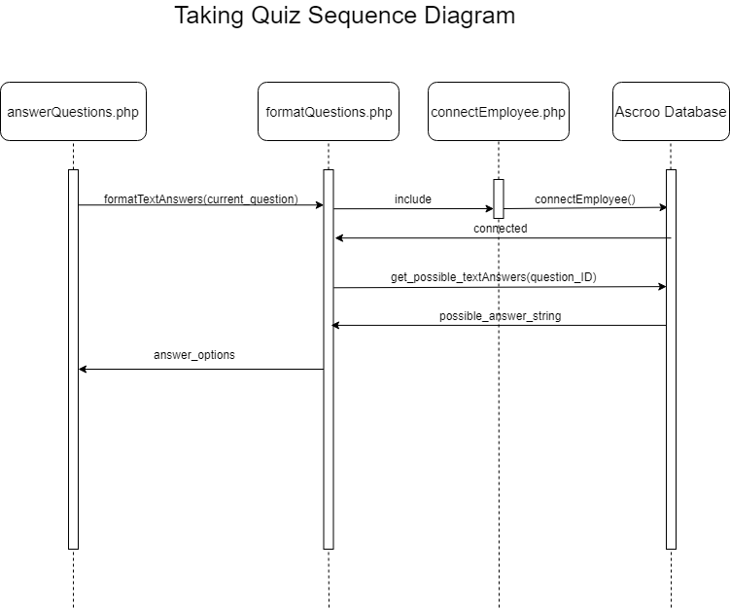

**4.7 Grading Questions**

After a question is answered it is immediately graded and the correct answer is shown afterwards. After the correct answer is displayed to the user the user is prompted to move on to the next question where they can repeat the cycle until there are no more questions left and they can view their grade for the quiz.

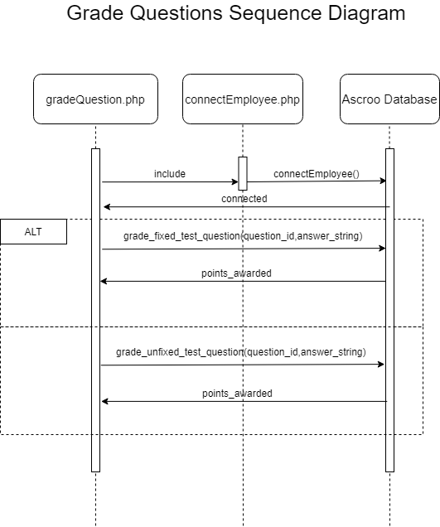

***5. Glossary***

|  |  |
| --- | --- |
| O/S | Operating System |
| I/O | Input/Output |
| Employee | A user that is restricted from accessing mentor specific privileges such as managing users, creating users, and managing other user’s quizzes |
| Mentor | A user that has access to all of the functionality of the website |
| Delimiter | A delimiter is a sequence of one or more characters for specifying the boundary between separate, independent regions in plain text or other data streams. |
| PHP | PHP is a general-purpose programming language originally designed for web development |